



METHODS Unit 1

YEAR 11

TEST 2 : CHAPTER 3 - 6
Functions, Linear functions, Quadratic functions and equations

Question/Answer Booklet

Student Name : ______________________________

Teacher : Mrs Erna Burger

Time allowed for this paper
Working time: fifty minutes

Materials required/recommended for this paper

To be provided by the supervisor
This Question/Answer Booklet
Formula Sheet

To be provided by the candidate
Standard items: pens, pencils, pencil sharpener, eraser, correction fluid/tape, ruler, highlighters

Special items: Drawing instruments, one A4 double-sided page of notes, templates and 3 calculators satisfying the conditions set by the Curriculum Council.

Important note to candidates

No other items may be used in this section of the examination. It is your responsibility to ensure that you do not have any unauthorised notes or other items of a non-personal nature in the examination room. If you have any unauthorised material with you, hand it to the supervisor before reading any further.

Answer ALL questions.

Show all working clearly, in sufficient detail to allow your answers to be checked readily and for marks to be awarded for reasoning. Incorrect answers given without supporting reasoning cannot be allocated any marks.

Mathematics Methods 1: Test 1 Non-Resource Section
Functions, Linear functions, Quadratic functions and equations

Time for this section: 30 minutes Marks for this section: 26

No calculators or notes allowed for this section.

1. [8 marks]

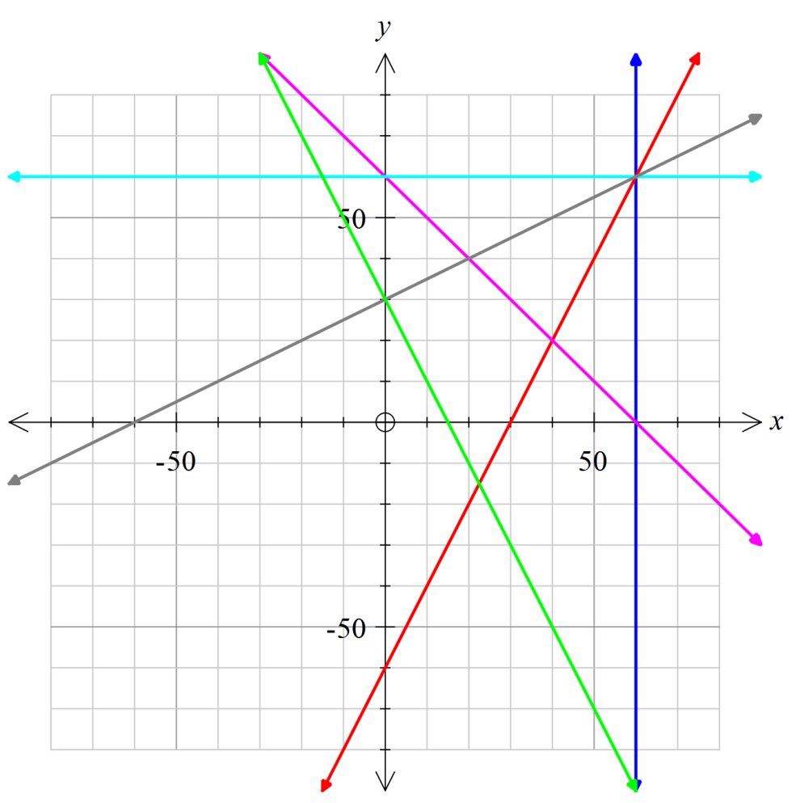The display on the right shows lines labelled A to F.
A
B
C
D
E
F

(a) Give the equation of line D: (1)

(b) Which one of the given lines are
perpendicular to line D?

Why? (2)

(c) Give the equations of another
set of the given lines that are
perpendicular. (2)

(d) Complete: The gradient of the line that goes through the point (20, –20) is ________
(number value) and the coordinates of the y–intercept is _________. This line intersect
a few other lines; give the equation of such a line: _______________________. (3)

2. [12 marks]

The graphs of functions f(x) = – x ² + 2x

and g(x) = x ² – 4x are shown below.

Use the graphs to answer the following questions:

- Give the equation of the axis of symmetry of f(x). (1)

- What is the coordinates of the turning point of g(x)? (1)

- Find the constant value(s) of k where f(k) = g(k). (2)

- For the graph of h(x) = –(x – 1)(x – 2) determine

(i) the nature and location of the turning point (2)

(ii) the coordinates of the y–intercept (2)

(iii) the coordinates of the x–intercept(s) (2)

(iv) Show these features on the grid above. (2)

3. [6 marks]

For f(x) = $\sqrt{x+2}$ and g(x) = 2x – 1 , determine each of the following:

(a) the natural domain and corresponding range of f(x). (2)

(b) g(–1) (1)

(c) the value(s) of r given that f(r) = r (3)

Name : _______________________________

Mathematics Methods 1: Test 2 Resource Section
Functions, Linear functions, Quadratic functions and equations

Time for this section: 20 minutes Marks for this section : 17

Up to 3 calculators & 1 A4 page of notes allowed for this section.

5. [10 marks]

(a) Use completing the square to show that the equation 3x² – x + 1 = 0, has no solution. (4)

(b) The graph of the y = 4x² – 12x + c has

(i) exactly one root; find the value of c. (2)

(ii) an x–intercept at (4, 0). What is the value of c? (2)

Find the roots of the graph. (2)

6. [3 marks]

Consider the line ax + 2y = c where c is a constant.

(a) Find the value of a if this line has a gradient of 4. (2)

(b) Find the value of c if this line has a y–intercept of 2. (1)

7. [4 marks]

The photo on the right shows a bridge across a river.
y
x
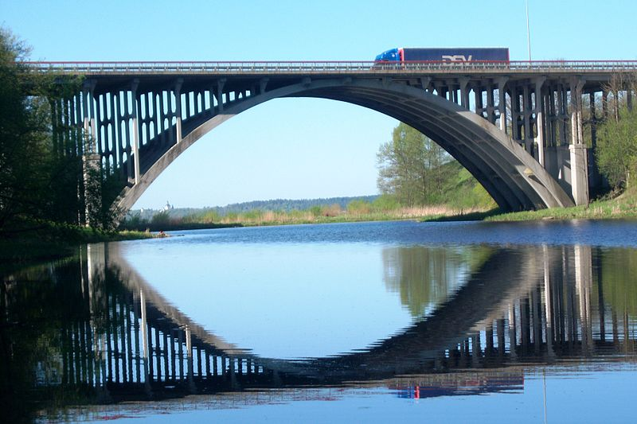
With the x and y axes as shown the bridge arch has equation
y = $\frac{5x}{16}$ (8 – x)

Determine

(a) the width of the river flowing
underneath the bridge. (2)

(b) the clearance underneath the
bridge at the centre (2)

